Priority-Based Scheduling
# Source: AI Source: Provided by: [Data Path: Persons Table -> ID Column: 1, Name_En Column: Motasem Essam] -> From: [ChatGPT] on [1/21/2026]
Priority-Based Scheduling is a fundamental scheduling technique in Real-Time Systems (RTS) where each task is assigned a priority, and the CPU always executes the highest-priority ready task first. It can be static or dynamic, depending on whether priorities are fixed or change at runtime.

Definition
# Source: AI Source: Provided by: [Data Path: Persons Table -> ID Column: 1, Name_En Column: Motasem Essam] -> From: [ChatGPT] on [1/21/2026]
Priority-Based Scheduling is a method where:
- Tasks are assigned priorities based on importance, deadlines, or system requirements.
- The scheduler selects the task with the highest priority to run next.
- If a higher-priority task becomes ready, it can preempt a lower-priority task.

Key Features
# Source: AI Source: Provided by: [Data Path: Persons Table -> ID Column: 1, Name_En Column: Motasem Essam] -> From: [ChatGPT] on [1/21/2026]
- Preemptive or Non-Preemptive:
  - Preemptive: Higher-priority tasks can interrupt lower-priority tasks.
  - Non-Preemptive: A running task completes before the scheduler checks for higher-priority tasks.
- Flexible Priority Assignment:
  - Static Priority: Fixed during design (e.g., RMS).
  - Dynamic Priority: Can change at runtime based on deadlines or urgency (e.g., EDF, LLF).
- Deadline-Oriented: Higher-priority tasks often correspond to tasks with more urgent deadlines.

Advantages
# Source: AI Source: Provided by: [Data Path: Persons Table -> ID Column: 1, Name_En Column: Motasem Essam] -> From: [ChatGPT] on [1/21/2026]
- Supports Critical Tasks: Ensures high-priority tasks meet deadlines.
- Flexible: Can be applied to both hard and soft real-time systems.
- Efficient CPU Utilization: Ensures important tasks are not delayed.

Disadvantages
# Source: AI Source: Provided by: [Data Path: Persons Table -> ID Column: 1, Name_En Column: Motasem Essam] -> From: [ChatGPT] on [1/21/2026]
- Priority Inversion: Lower-priority tasks holding a resource may block higher-priority tasks.
- Starvation Risk: Low-priority tasks may never execute if high-priority tasks keep arriving.
- Complexity in Dynamic Systems: Requires careful management of dynamic priorities.

Example
# Source: AI Source: Provided by: [Data Path: Persons Table -> ID Column: 1, Name_En Column: Motasem Essam] -> From: [ChatGPT] on [1/21/2026]
Suppose we have three tasks:
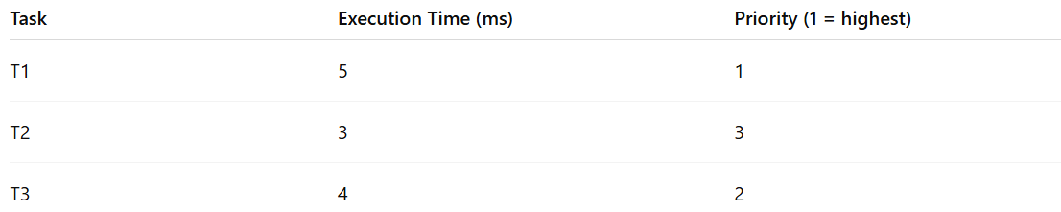
Task | Execution Time (ms) | Priority (1 = highest)
T1 | 5 | 1
T2 | 3 | 3
T3 | 4 | 2
- Execution Order (Preemptive): T1 → T3 → T2
- T1 runs first because it has the highest priority.
- If T1 is executing and T3 becomes ready, it preempts T2 if necessary.

Why Priority-Based Scheduling Matters for Software Engineers
# Source: AI Source: Provided by: [Data Path: Persons Table -> ID Column: 1, Name_En Column: Motasem Essam] -> From: [ChatGPT] on [1/21/2026]
- Core concept in hard and soft real-time systems.
- Teaches task prioritization, preemption, and scheduling trade-offs.
- Helps in designing RTOS-based applications for robotics, automotive, industrial automation, and multimedia systems.

